Website Breakdown
Website breakdown:
- Home page:
  - Mission statement (short)
  - Donate now button
  - Recent highlights/shipments
  - Impact map, stats, KPIs
    - Link KPI dashboard (another page)
  - How Bloops work/daily operations
  - Publications
- Mission (org focused):
  - Mission statement & something else
  - The problem
    - medical supply waste/medical supply inequity
    - UJPH article
  - Our process/our departments
    - Four departments
    - Shipment process
- Impact (basically shipments) -
  - Impact map
  - Photos & more in-depth descriptions of each shipment
  - Putting KPI dashboard slides (swipe through) on wix
  - Community impact
    - DOS
    - High school outreach
    - OSU mental health
    - USC stuff
- Press (all one page)
  - Most recent article/press
  - Our Chapters (our chapters recent activity, shipments, updates) (UofM, USC, etc)
  - Education (UJPH, Public Policy, etc)
  - Separation
  - Find us more in the news
    - Social media (instagram linked to site, scroll)
    - All the older/miscellaneous articles
- About Us (More people focused)
  - Information about when established, UofM, general about us (students, non profit, MRSO, etc)
    - UMICH chapter: our HQ executive team
    - Chapter 1
    - Chapter 2
    - Chapter 3
    - Chapter 4
    - Chapter 5
    - Chapter 6
    - Chapter 7
    - Chapter 8
- Get Involved
  - Start a university chapter
  - Start a high school club
  - Become a Partner/Collaborate with us
    - Our previous/current partners
    - Corporate sponsor (money and advertising)
    - supplier/donor partner (giving us supplies)
    - Another student org/nonprofit wanting to collaborate
  - Donate (supplies and/or money)
  - Looking for supplies? (we give you supplies)

Header Tab
This is everything that is going at the top of the website

Footer Tab
This is everything that is going at the bottom of the website

Home Page
- Home page:
  - Mission statement (short)
    - Every year, over 5 billion pounds of medical supplies, much of it unused, are wasted. At Blueprints for Pangaea, we work to reallocate essential supplies from areas of surplus to communities in need.
  - Donate now button
  - Recent highlights/shipments

  - Map of countries we’ve shipped to —> button to get to our impact page ‘learn more’
  - Few Key Stats, KPIs
    - Include consolidated diagrams from KPI project dashboard (/key metrics from executive summary)
    - Impact:
      - More than $6.8 Million of unused medical supplies reallocated to communities in need.
      - 15+ Countries Donated: From Ukraine to Syria, B4P has donated medical supplies to various locations worldwide.
      - 10 National Chapters: The University of Michigan (Headquarters), Michigan State University, Ohio State University, Wayne State University, University of Southern California, Rutgers University, Washington University, University of Miami Medical School, Santa Clara University, and New York University.
      - 10+ Years: For over 10 years, Blueprints for Pangaea has been working to address healthcare inequities and contribute to a more sustainable healthcare system.
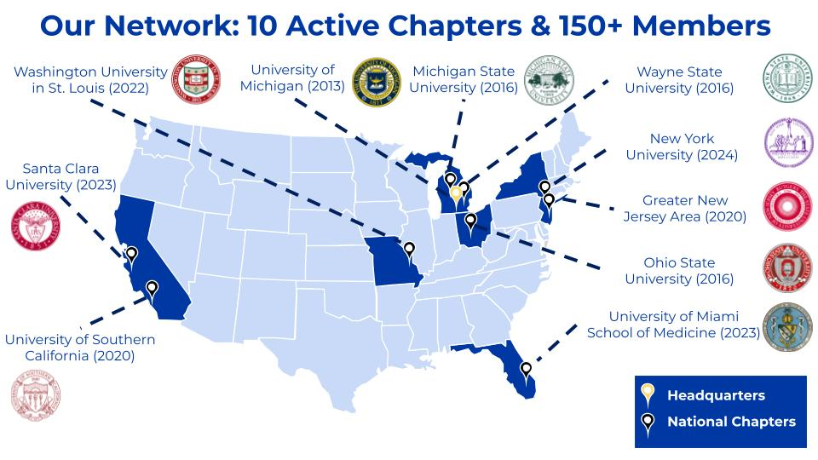
  - How Bloops work/daily operations
    - Organizational overview:
      - We are a student-led nonprofit operating through a growing network of university chapters and high school clubs. By partnering with hospitals and suppliers to collect donated resources, we help reduce waste, cut costs, and improve sustainability on the supply side. These supplies are then distributed to clinics and hospitals in need both at heavily subsidized rates, supporting affordable, higher-quality patient care in resource-limited settings.
      - Process: Graphic/highlights not going in-depth (in-depth with media, examples, past, etc can be on mission page)
  - Brief about our org video/general
  - Publications
    - Recent publications

Mission
- Mission (org focused):
  - Mission statement & something else
    - Blueprints for Pangaea (B4P) is a nonprofit medical surplus recovery organization (MSRO) that reallocates unused medical supplies from areas of surplus to communities in need. Through our growing network of university chapters and high school clubs, we collect surplus medical supplies and redistribute them to underserved communities locally and internationally.
  - The problem
    - Around the world, billions of people lack access to basic medical supplies and equipment, while the U.S. healthcare system discards over 5 billion pounds of unused medical supplies each year.
  - Our process/our departments
    - Four departments
      - Development:
        - Old: Development aims to engage the local Ann Arbor and Metro Detroit community in Blueprints' mission as well as spread our mission across various platforms.
        - New: The Development Department oversees public perception and understanding of our mission, and we work with various communities in Ann Arbor and Metro Detroit to raise awareness and spread our mission across various platforms.
          - Development manages five key pillars, which are focused more heavily on in the Development Core Team.
            - High School Engagement and Expansion
            - Digital Operations and Content Management
            - News/Media and Publications
            - Community Outreach
            - Education
      - Expansion:
        - Old: Expansion manages and oversees our national chapters by aiding them in their operations and budgeting.
        - New: The Expansion Department supports the national growth of Blueprints, ensuring the successful development of chapters.
          - Oversee and consult with all 11 chapters on their operational, financial, and developmental processes
          - Review applications and conduct interviews to evaluate prospective chapters
          - Incorporate advocacy and public policy in organization-wide initiatives to enhance impact
      - Operations:
        - Old: Operations is responsible for coordinating and carrying out local and international shipments. Operations also oversees the maintenance of our supplies warehouse.
        - New: The Operations Department oversees the entire supply chain to deliver value to communities in need. To date, we have shipped over $6 million worth of medical supplies! In addition to sending out shipments, operations is also in charge of maintaining the inventory Blueprint’s carries, as well as developing new tools and processes (such as our ML/AI Web App) to improve inventory speed and accuracy.
      - Finance:
        - Old: Finance is responsible for managing and sourcing funds for Blueprints' day to day operations through grants and fundraisers.
        - New: Finance handles some KPI quantification but mainly handles fundraising initiatives for the organization to ensure sustainability and growth through 3 main methods:
          - Grants: Apply to 10-12 internal and external grants a year to fund a majority of our expenses
          - Fundraisers: Utilize proximity with the local campus community and organizations to hold fundraisers and National fundraisers such as Giving Tuesday
          - Sponsorships/Partnerships: Leverage connections with companies ranging from local to F500 to create a mutually beneficial relationship (e.g. Celsius & Colgate)
      - NEW DEPARTMENT VIDEOS
    - Shipment process
      - Partner: Our chapter locations at universities across the country partner with affiliated university medical centers and other local clinics to collect surplus medical supplies.
      - Collect: These supplies are transported to one of our storage warehouses, where they are then inventoried and stored until a sufficient quantity for shipment has been collected.
      - Verify: We work with nonprofit partners to verify medical supply quality and integrity. Supplies are then sorted and prepared for shipment.
      - Ship: Blueprints for Pangaea, independently, or via a nonprofit partner, arranges for transport of the supplies. These shipments are then sent to communities in need across the globe.
        - Same graphic as homepage but interactive
          - Include photos, videos, cases/examples (not necessarily)

Impact
- Impact (basically shipments) -

  - Impact map
    - Get Impact map from KPI dashboard project by Friday morning
    - If not available, generate map using available KPIs for each shipment
      - “At Blueprints for Pangaea, our impact encompasses the globe. Here are the countries we have donated supplies to:”
      - Using the impact map we have now: click on countries (e.g. United States) for specific shipments and stories
        - This would connect to the “more shipments” page
    - Interactive map (headquarters only)
      - For every shipment (or all that you can find):
        - Date of Shipment:
        - Name of Recipient:
        - Type of Supplies Shipped:
        - Shipment Size:
        - Estimated Valuation:
  - Shipments
    - Shipment highlights
      - Including a map, similar to operation smile where all shipments are displayed and you can click on each one for information to pop up
        - Need to be done
      - Insert three recent shipment highlights that can be updated bi-yearly
      - Page Button on the bottom middle of the three boxes: “More Shipments”
        - Button will lead to hidden (not in main tab category) to a list of all our shipments
      - Better layout → currently it's just a list that goes on forever
        - A sliding widget
        - A grid?
  - Our Stats
    - Insert KPI dashboard slides
    - Insert three most important KPIs
      - Total Value of Shipments
      - Total CO2 diverted (working on it) (can also talk about in sustainability section of website)
      - Total Shipments
  - Community impact
    - DOS
      - Pictures + stats on how many kits made, locations sent to, etc
    - High school clubs
    - High school outreach
      - Stats on number of high school chapters involved
      - Specific stories or impact spotlights from highschools
    - A2Zero Collaborator (sustainability coalition of Ann Arbor)
      - Add pictures
    - General community outreach project/initiatives
      - Mental health pamphlets (see expansion public policy project)
    - Summit
    - Case Comp
    - Fundraising events (thrift pop-up, food week, etc)
    - OSU mental health
    - USC stuff

About Us
- About Us (More people focused) Chapter Website Updates (Last Updated 8/23)
  - Information about when established, UofM, general about us (students, non profit, MRSO, etc)
    - 11 Chapters (including UofM)
    - THE UNIVERSITY OF MICHIGAN
      - CEO: Stephanie Chan
      - Blueprints Headquarters and Founding Chapter since 2013
      - contact@b4pglobal.org
      - C-Suite
      - VPs
      - Analysts
      - Interns
    - MICHIGAN STATE UNIVERSITY
      - Pres: Maya Marina
      - Chapter since 2016
      - blueprintsforpangaea-michiganstate@b4pglobal.org
    - THE OHIO STATE UNIVERSITY
      - Pres: Siddharth Varman & Naomi Mukka
      - Chapter since 2016
      - blueprintsforpangaea-ohiostate@b4pglobal.org
      - CHAPTER PROJECT: Affordable Mental Health Care Resource Guide https://www.blueprintsforpangaea.org/_files/ugd/36437b_98e71d8b0976424880c1c2cfbf7b451f.pdf
    - WAYNE STATE UNIVERSITY
      - ​Pres: Deidre Nicole Crockett
      - Chapter since 2017
      - blueprintsforpangaea-waynestate@b4pglobal.org
    - UNIVERSITY OF SOUTHERN CALIFORNIA
      - Pres: Karen Lee
      - Chapter since 2020
      - blueprintsforpangaea-usc@b4pglobal.org
    - RUTGERS UNIVERSITY
      - Pres: Pranav Manchiraju
      - Chapter since 2020
      - b4p-rutgers@b4pglobal.org
    - WASHINGTON UNIVERSITY
      - Pres: Alina Alqazaha
      - Chapter since 2022
      - b4pangaea@gmail.com
    - UNIVERSITY OF MIAMI MEDICAL SCHOOL
      - Pres: Alex Pedowitz
      - Chapter since 2023
      - ajp365@med.miami.edu
    - SANTA CLARA UNIVERSITY B4P SCU Chapter Website Updates
      - Pres: Senit Ghile
      - Chapter since 2023
      - sghile@scu.edu
    - NEW YORK UNIVERSITY
      - Pres: Keya Chhabra
      - Chapter since 2024
      - kc5125@nyu.edu
    - UNIVERSITY OF NEBRASKA OMAHA
      - Pres: Abby Lauder & Amina Hussain
      - Chapter since 2025

Press
- Press (all one page)
  - For each (publisher, date published, title, brief description or first paragraph, authors, image, link it to their website (to publishers website)
  - Highlight if was bloops people
  - Divide into 3 sections
    - Our Chapters (our chapters recent activity, shipments, updates) (UofM, USC, etc)
      - UofM
      - USC
      - Etc
    - Education (UJPH, Public Policy, etc)
      - Medical supply waste
      - Public policy paper
    - Find us more in the news
      - Social media (instagram linked to site, scroll)
      - All the older/miscellaneous articles
  - Graphics, interesting features to put on page??

Get Involved
- Get Involved
  - Start a university chapter
    - Reach out to expansion for what to highlight
    - Make a google (see what ones expansion has) for general information and collecting info from those interested
    - What is a university chapter
    - Examples
    - Q&A
  - Start a high school club
    - What is a high school club
    - Examples
    - Q&A
  - Become a Partner/Collaborate with us
    - Information for contact
    - Supplier/donor partner (giving us supplies)
      - Define
      - Hospital partner established 10/24/2018
      - Demonstrate process
      - Do not mention michigan med specifically (we want to keep this vague)
    - Can mention previous partners (i.e. student orgs, DOS partners)
  - Donate (supplies and/or money)
    - Donation writeup for money, where it goes, paying for shipments, specific about shipment process, etc
    - Donation writeup for supplies (get from Ops/Helen what we can (more descriptive))
  - Looking for supplies? (we give you supplies)
    - Writeup for recipients who are interested/in need

